**DATA ANALYSIS: PYMOJI**

Given the data provided one can be led to three very certain conclusions about Pymoji, it’s customers and it’s pricing model. First and foremost, Pymoji is heavily dominated by male customers with 84% of the total number of customers provided in the data set being male. Furthermore, Pymoji’s customers also fall into a very defined age range as well with 77% of the total customers provided by the data set falling in the range of 15 to 30 years old. In maybe more surprising news, the data doesn’t indicate the price to be a motivating factor on purchases. All of the five most popular purchases were above the average price spent per item in general.

**GENDER BREAKDOWN REPORT**

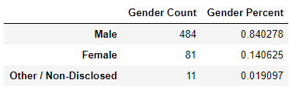

**AGE BREAKDOWN REPORT**

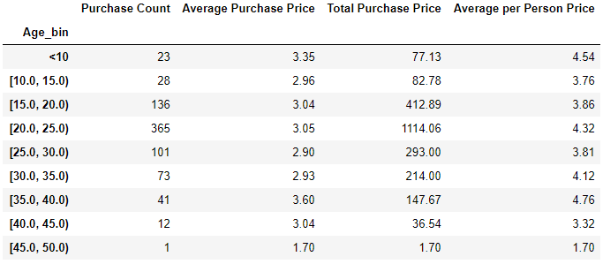

**MOST POPULAR GAMES VS PRICEPOINT**

The top five most popular games cost well above the average price spent in Pymoji. Leading one to possibly conclude price is not the ultimate deciding factor for customers when purchasing within Pymoji. According to the data, if the item in Pymoji is attractive enough to the customer based on what if offers then price a higher price is not enough to deter a customer from making the purchase.

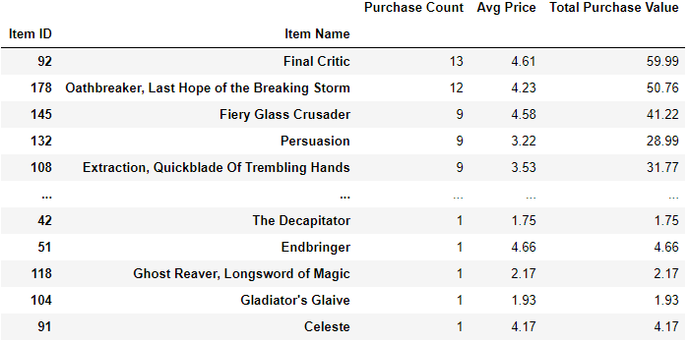

**CONCLUSION**

The male, 15-30 market is the largest sector of the customer base for Pymoji. More digital marketing should be spent on that demographic to increase the overall customer base since it’s proven that demographic is a strong customer. On the other side of that coin there is a massive area of potential growth in the female market. Also, more data is needed to consider adjusting the price point but there is enough data to suggest the price point may not be at the ceiling just yet since the most popular items sold are also some of the most expensive. Pymoji For Life.